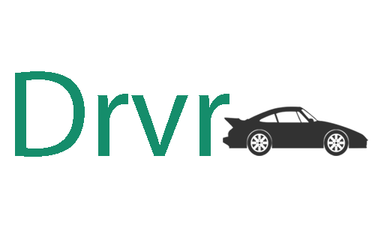

Drvr User Manual

Thanks for downloading Drvr. This manual is designed to assist in the setup and usage of the application. We hope you will enjoy using this application!

Kapil Haresh Vigneswaren

Ng Shien Wee

Hui Jia Yeoh

Dyalan Shanmugarajah

Version Change log:

|  |  |  |  |
| --- | --- | --- | --- |
| **Version** | **Changes made by** | **Changes made** | **Date** |
| 1.0 | Hui Jia Yeoh | * Added Overview, Objectives, Installation (incomplete). * Inserted Infographics, Simulation, Quiz section. Images used were mock-ups done by Kapil. * Infographics guide added but with no suitable screens to add. The same thing goes for quiz | 30-4-2015 |
| 2.0 | Hui Jia Yeoh | * Updated Infographics and Quiz content according to the meeting held on 1-5-2015. * Added version updates section to keep track of changes made when, where and by whom. | 2-5-2015 |
| 3.0 | Hui Jia Yeoh | * Updated simulation section * Added components based on Shien Wee’s use case and Kapil’s functionality description. * Added some icon description (icons that will be used in the program)   Icon credits: Icon made by [Freepik](http://www.freepik.com/) from www.flaticon.com | 14-5-2015 |
| 4.0 | Hui Jia Yeoh | * Modified a little bit at the ‘Results’ section of the Quiz segment. * Added main menu mock-up screen. * Added infographics mock-up screen | 16-5-2015 |
| 5.0 | Hui Jia Yeoh | * Added more mock-ups (including the ones for simulation and the quiz) * Edited some minor details off at the Simulation’s explanation. * Added ‘System Requirements’ – details are based off Kapil’s deliverable. * Created Table of Contents * Added setup steps mock-ups/images (could be either) | 19-5-2015 |
| 6.0 | Kapil Haresh Vigneswaren | * Redid formatting and grammar check | 31-5-2015 |

Table of Contents

**1.** **Overview** 4

**2.** **Objectives** 4

3. **System Requirements** 4

**4.** **Installation** 5

**5.** **Introducing Drvr** 7

**5.1.** **Learning with Infographics** 7

5.1.1. VIEW 8

5.1.2. COMPONENTS LIST 9

5.1.3. DESCRIPTION BOX 9

5.1.4. MISCELLANEOUS 10

**5.2.** **Understanding with Simulation** 11

5.2.1. Wheel Drive System 13

5.2.2. Fuel System 13

5.2.3. Cooling System 13

5.2.4. Electrical System 15

5.2.4.1. Lights 15

5.2.4.2. Wipers 16

5.2.4.3. Audio 16

5.2.4.4. Cruise Control 16

5.2.4.5. Defrost Rear 16

5.2.5. Steering System 17

5.2.6. Braking System 17

5.2.6.1. Hand Brake 17

5.2.6.2. Foot Brake 17

5.2.7. Adding Attachment 18

5.2.8. Alternate Fuel Powered Drivetrains 18

5.2.9. High Altitude Driving 19

**5.3.** **Test yourself with the Quiz** 20

5.3.1. During the quiz 20

5.3.2. Results 21

# Overview

Ever wondered how much you know about your car and how it works on the inside? Let Drvr take you through an immersive learning experience to further develop your knowledge on the four wheel automobile you have been or will be driving!

Drvr’s three components will take you on a drive on the learning lane, allowing you to experience informative infographics, interactive systems simulation and challenging quizzes to enhance your understanding on how a car works.

# Objectives

Drvr has the following objectives:

* To produce informed users by polishing/improving their knowledge on cars
* To allow users to understand how the components in the car interact.
* To allow users to put the knowledge they have acquired to test.

# System Requirements

* OS: Windows 8 and above
* CPU: 1 GHz x86/x64 Intel or AMD Processor or better
* Memory: At least 1GB RAM
* Graphics: Integrated Graphics
* Hard Drive: At least 2GB available on the hard disk
* Hardware: Mouse and/or Keyboard
* Software: Any web browser
* Screen resolution: 1024x768 and above

# Installation

* 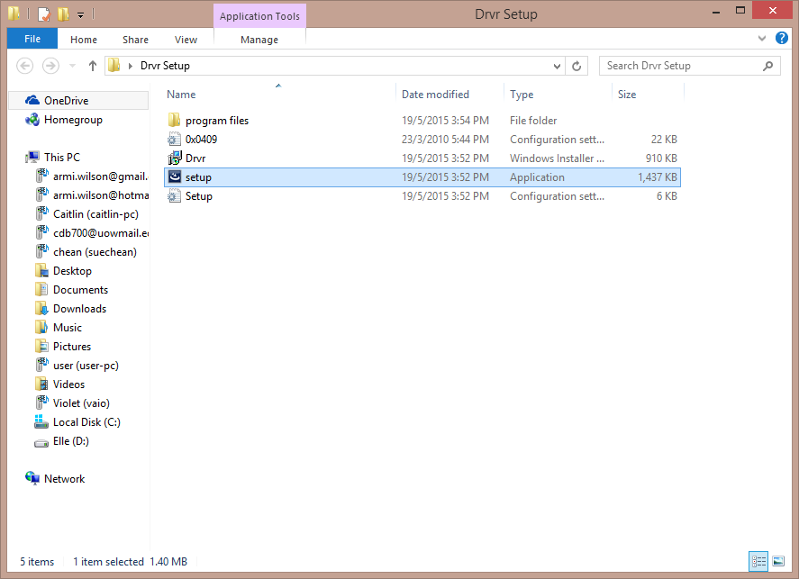Run the setup file that comes with this manual.

Figure : Locate the setup file and run it

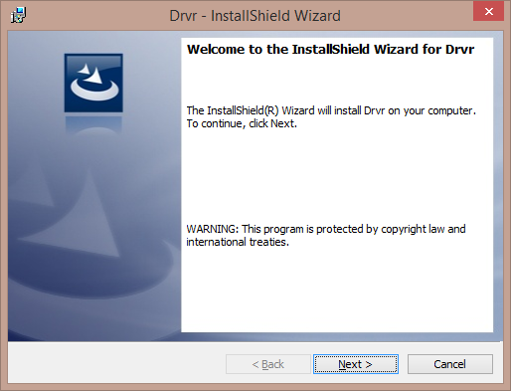

Figure ii: Follow the instructions on the setup

* Click on ‘Next’ to proceed. Choose ‘I accept the terms in the license agreement’ in the License Agreement screen.
* You will be able to choose where to install the program if the default directory is not desired.
* Once confirmed, click on ‘Install’ to proceed with the installation.

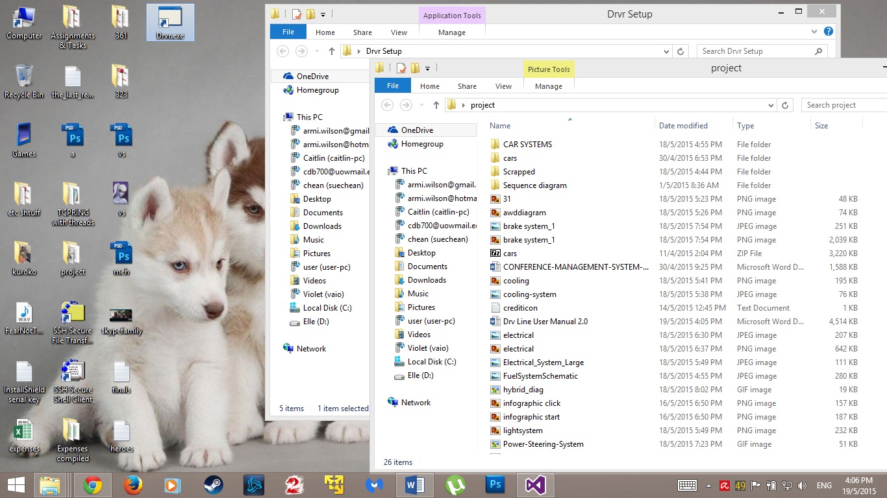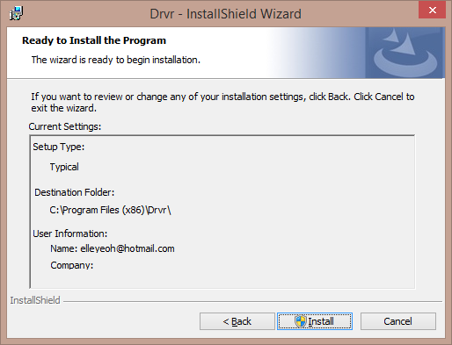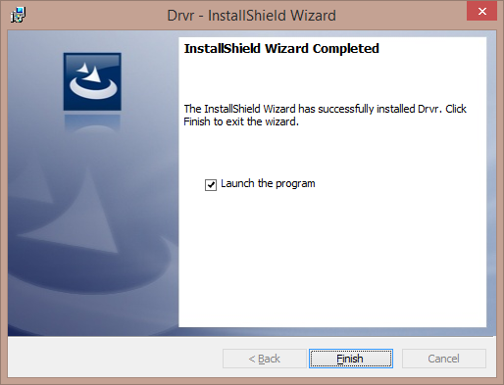

Figure : Confirm the details of your installation

Figure v: Installation is complete! You can launch the program now

* You can also run the program straight from the shortcut created on the desktop.

# Introducing Drvr

Figure A: Welcome to Drvr

Starting the program will bring you to the main menu page as show in Figure A. There are three choices that you can choose from:

1. Infographics
2. Simulation
3. Quiz

We highly recommend you start top first to allow the best learning experience as the Infographics and Simulation will teach you about most things you need to know about your car! Only then we would recommend you to take up a timed quiz that the development team has prepared for you to test how much you have come to understand!

## Learning with Infographics

Choosing the Infographics option from the main menu will bring you to a screen as shown in figure 1.1. The infographics will allow you to learn through brief descriptions, highlighted parts of the car and video links.

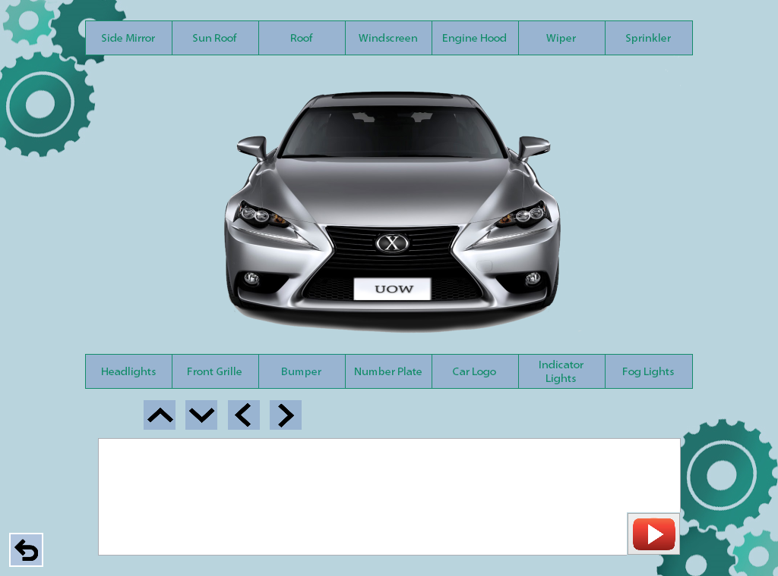

Figure 1.1:: Infographics Main Screen

### VIEW

* You will be able to see different parts and views of the car by clicking on either the left or right arrow that cycles through the ‘Front’, ‘Rear’, ‘Side’, ‘Top and ‘Interior’ view of the car.
* Choosing the up or down arrow will take you to a zoomed in or out perspective of the car of the view you have chosen.



Switch to next view

Switch to previous view

Zoom out

Zoom in

### COMPONENTS LIST

* You will be able to select any component listed in this list to learn more about it.
* Description of the part can be found in the description box below the image.
* The component that you have selected will be highlighted on the car.
* 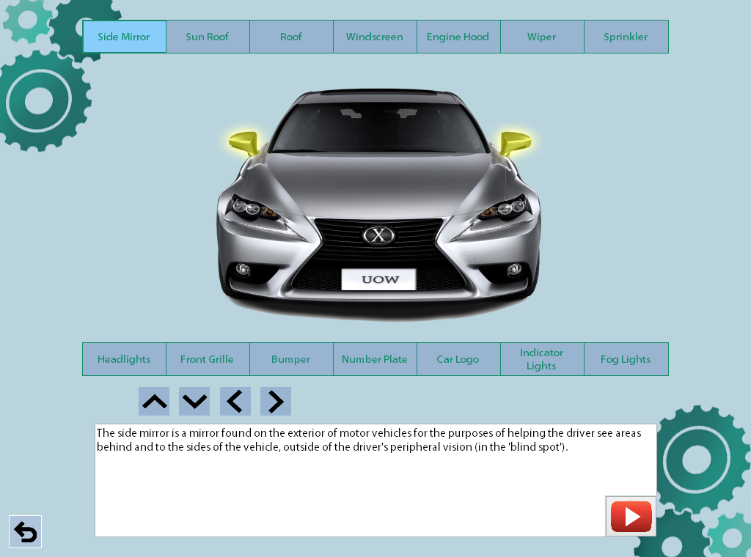In addition, you will also be able to click on any part of the car to learn more about it. The description of the part will be shown in the description box below the image and the respective component name will be highlighted.

Components List

Description Box

Change View

Figure 1.2: A component is highlighted and its description given

### DESCRIPTION BOX

* The description of the selected part will appear here.
* Besides that, there will be a button that links to a YouTube video for some parts to further describe the selected component. A pop up window will appear for this video to play as shown in figure 1.3.

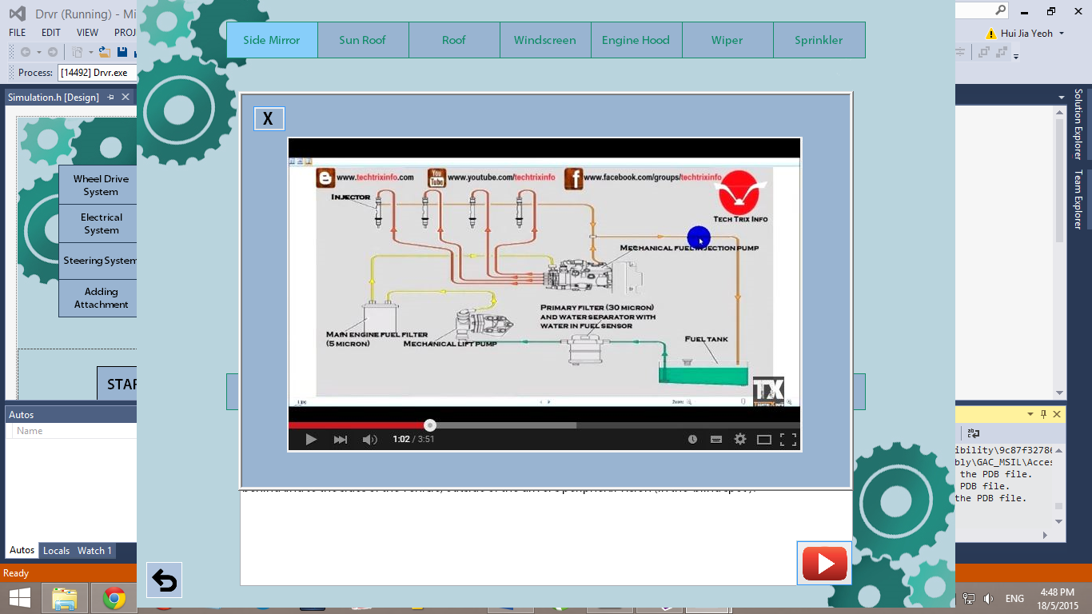

Figure 1.3: A popup with a video when the 'PLAY' button is clicked

## MISCELLANEOUS

Other buttons used in this part of the program:

 Return to Main Menu/Previous Screen

## Understanding with Simulation

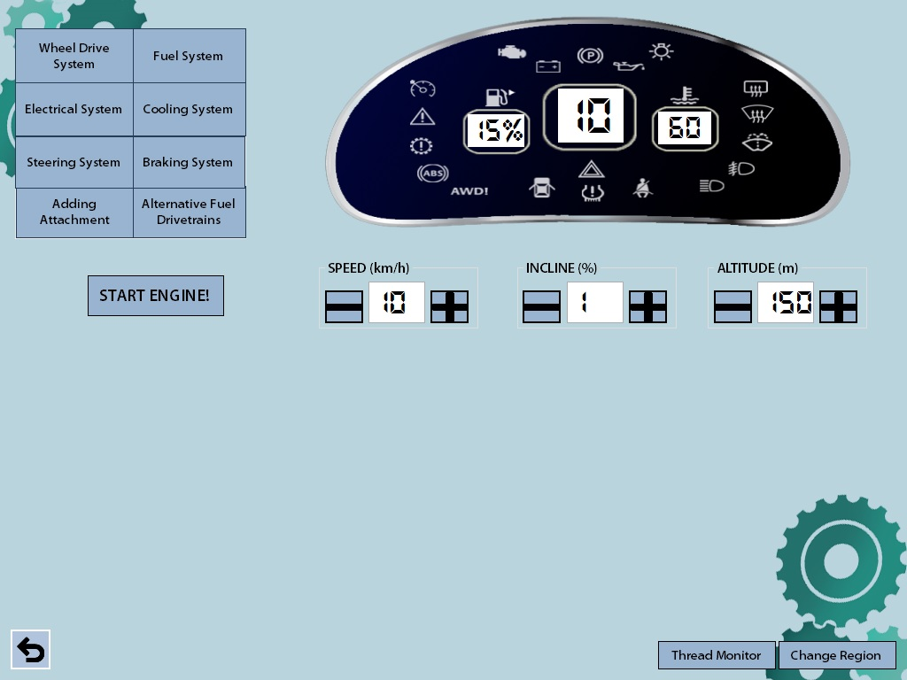Choosing simulation will take you to a screen which looks as shown in figure 2­­­.1.

Dashboard

Controls

System list

Figure 2.1: The Starting Screen under the simulation screen

The dashboard above will remain, allowing you to see what happens when certain circumstances occur- lighting up specific symbols and showing the present speed of your car. In addition, certain components on the instrument cluster will light up when situations such as low fuel or high temperature occurs.

If some terms are different in your region, you can choose to ‘Change Region’ (i.e. from United Kingdom to United States) to better suit your understanding.

Return to Main Menu/Previous Screen

Increment Value

Decrement Value



There is a total of 9 selectable systems and situations which you can view while the simulation is running:

1. Wheel Drive System
2. Fuel System
3. Cooling System
4. Electrical System
5. Steering System
6. Braking System
7. Adding Attachment
8. Alternative Fuel Powered Drivetrains
9. High Altitude Driving

You can start the engine by clicking the ‘START’ engine button and adjust the speed of the car accordingly. A digital speedometer will be displayed for you to keep track of your car’s speed in addition to your car’s fuel level and temperature. (REMEMBER: Your car won’t be moving at 0 km/h, so you will have to increase its speed). You can also adjust the inclination of the road your car is driving on to observe the relationship between inclination and fuel consumption.

Choosing a system or situation will bring up a panel below that shows you how the system works while the simulation is running. An example of the fuel system selected is shown below:

Figure 2.2: Example of the fuel system simulation panel below the persistent dashboard

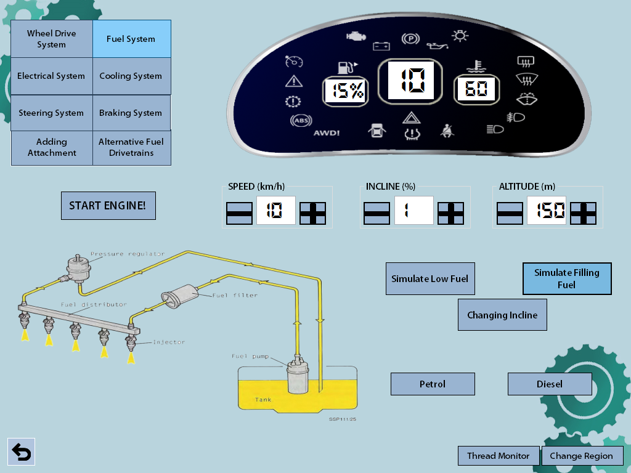

## Wheel Drive System

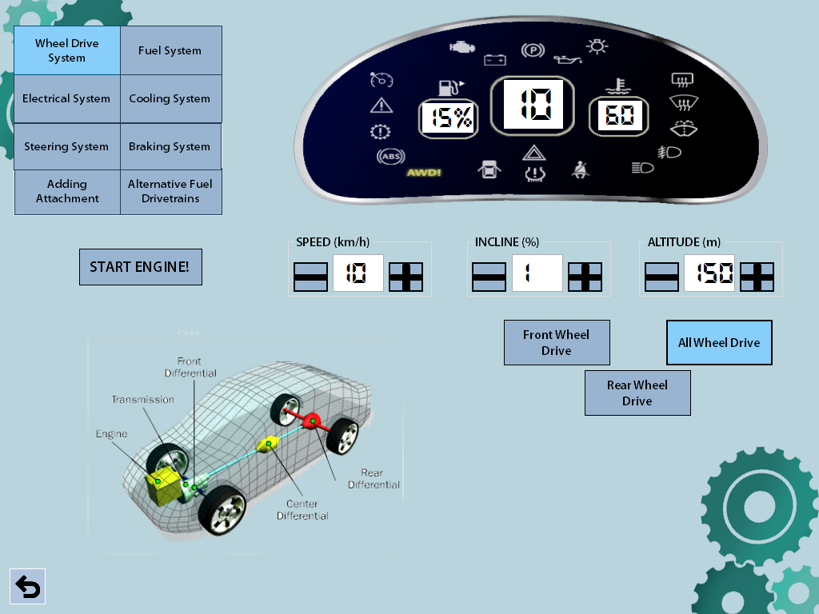You are able to choose between the front wheel drive, rear wheel drive and all-wheel drive mode but do ensure that you remember to stop your car and make sure you start the car engine again to watch the simulation of the drive mode you have selected!

Figure 2.3: Example of choosing all-wheel drive, where the AWD symbol on the dashboard lights up

## Fuel System

Selecting to view the fuel system will allow you to simulate what happens to the system when the car:

1. Is on low fuel
2. Is to fill fuel – will allow you to fill either petrol or diesel (see figure 2.2)
3. Is on an inclined road, and at a higher altitude

## Cooling System

The cooling system will show you how the car keeps its engine cool and what happens when it overheats. You will be able to choose between two conditions:

1. High temperature (Overheat)
2. 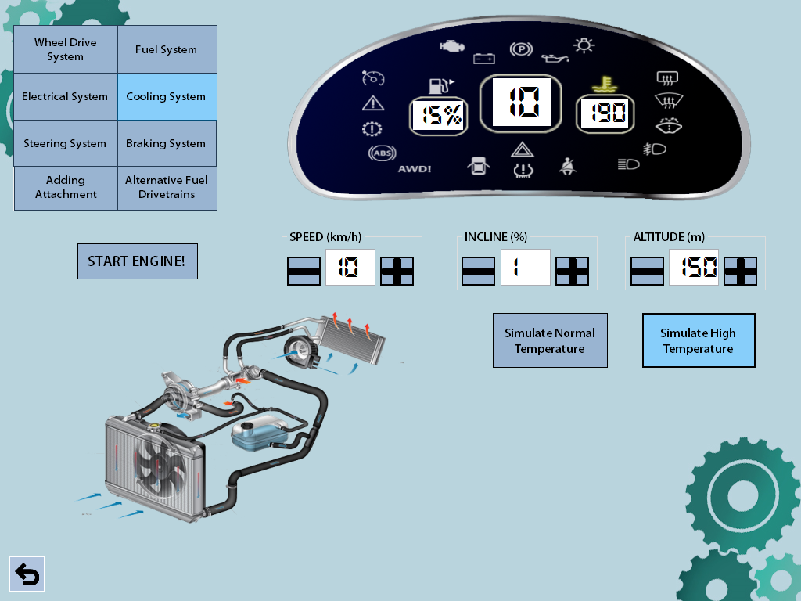Normal temperature

Figure 2.4: Simulation of overheating the car engine

## Electrical System

Selecting to view the Electrical System from the Simulation menu will bring you to this screen:

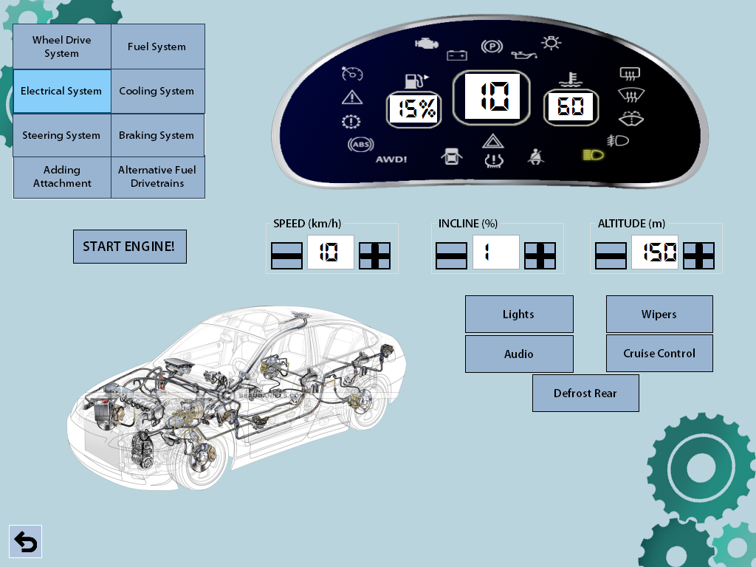You can choose to view any of these sub-systems under the electrical system:

Figure 2.5: Choosing the electrical system will bring this screen up

### Lights

Selecting to view the light components will allow you to choose between viewing how power is transmitted from the battery to the:

1. Headlights
2. Front Fog Lights
3. High Beam
4. Rear Fog Lights
5. Hazard Lights

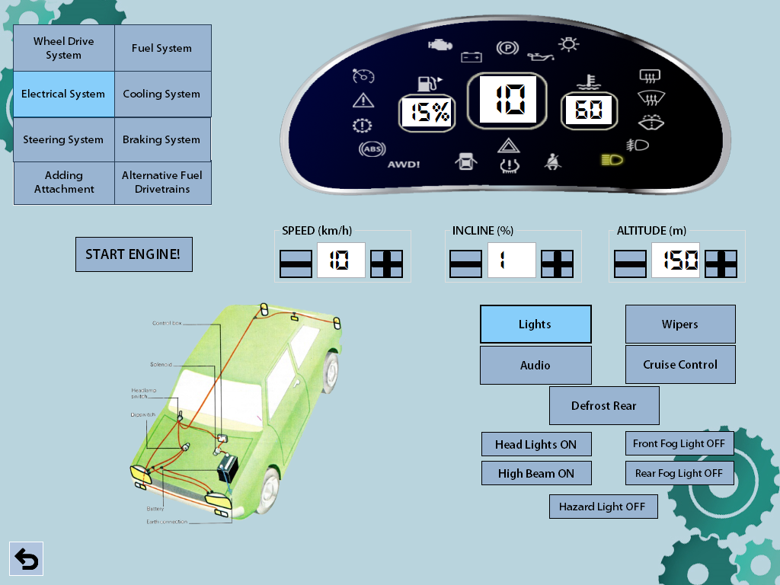

Figure 2.6: Example of The High Beam light turned on

### Wipers

Turning on the wipers will allow you to simulate how the wipers get its power. You will also be able to adjust the speed of the wiper from 1 to 3.

### Audio

Choosing to turn the audio on will show you how power is transmitter to the audio system. You will be able to adjust the volume of the audio as well as the radio channels.

### Cruise Control

The cruise control mode will be simulated when chosen and you will be able to adjust the speed of the cruise. Make sure you don’t leave your speed at 0 or your car will not move!

### Defrost Rear

You can simulate the activation of the rear heater of the car by choosing this option.

## Steering System

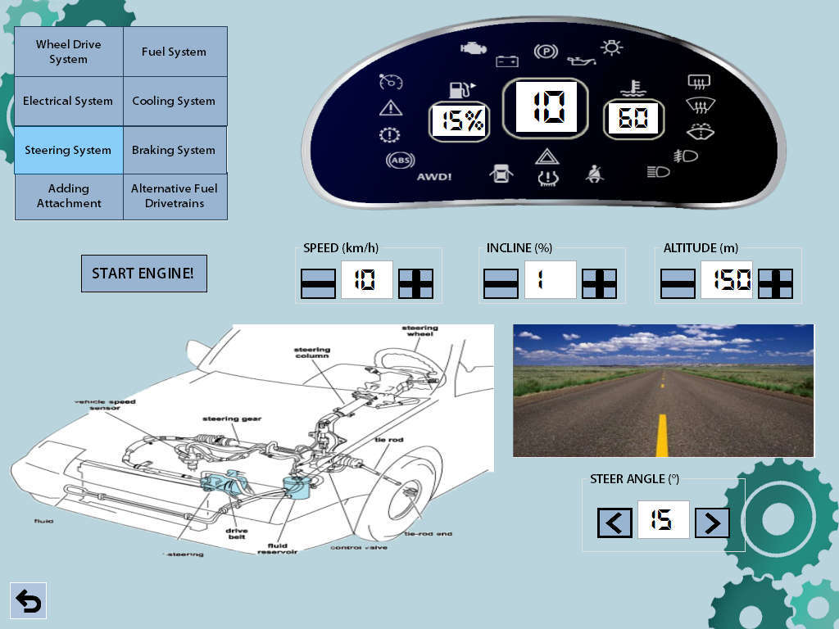The steering system will show you what happens when you turn the steering wheel and the limit of a car’s turn. By clicking left or right, the car will turn in the direction selected.

Figure 2.7: Simulation of the steering system

## Braking System

There will be two components, which you can trigger in when viewing the simulation under the braking system, namely:

### Hand Brake

Activating the hand brake will light the hand brake icon on the dashboard.

### Foot Brake

Holding the foot brake button will slow the car down at a fixed rate. Releasing will stop the reduction of speed.

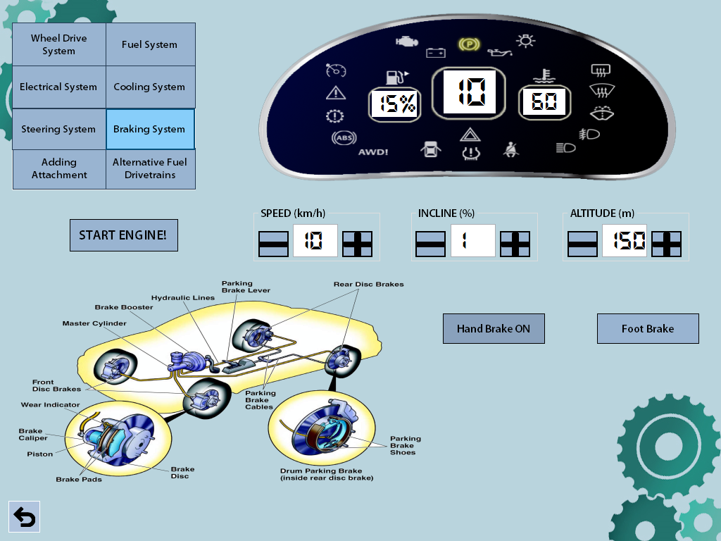

Figure 2.8: An Example of running the braking system with the hand brake on

## Adding Attachment

You can simulate what happens when you add an attachment to the car. The following are attachments, which you can add to the car:

1. Trailer
2. Tow Box

You can also unmount the attachment whenever required.

## Alternate Fuel Powered Drivetrains

This mode will simulate the car running on alternative fuel, namely:

1. Hybrid
2. Hydrogen
3. Electric

Each mode will describe how the car operates on these fuels to provide energy to the engine/motor.

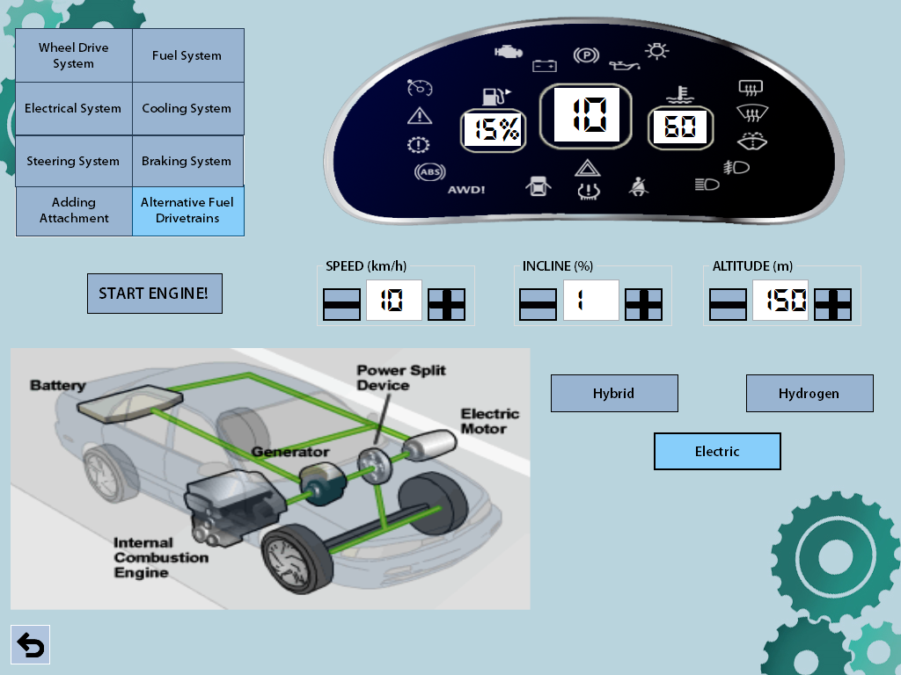

Figure 2.8: The screen showing how an electric car drivetrain works. You will be able to choose between three modes: Hybrid, Hydrogen or Electric drivetrains.

## High Altitude Driving

This simulation will show how driving on differing altitudes affect fuel consumption. You will be able to see the rate at how fuel is burnt against the altitude by adjusting the altitude of the car.

In addition to being able to test systems separately, you will also be able to view the status of the other components of the car under ‘Thread Monitor’. 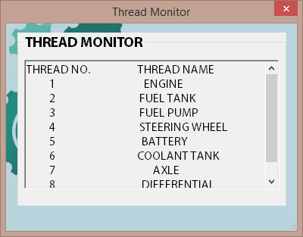

Figure 2.9: The Thread Monitor

## Test yourself with the Quiz

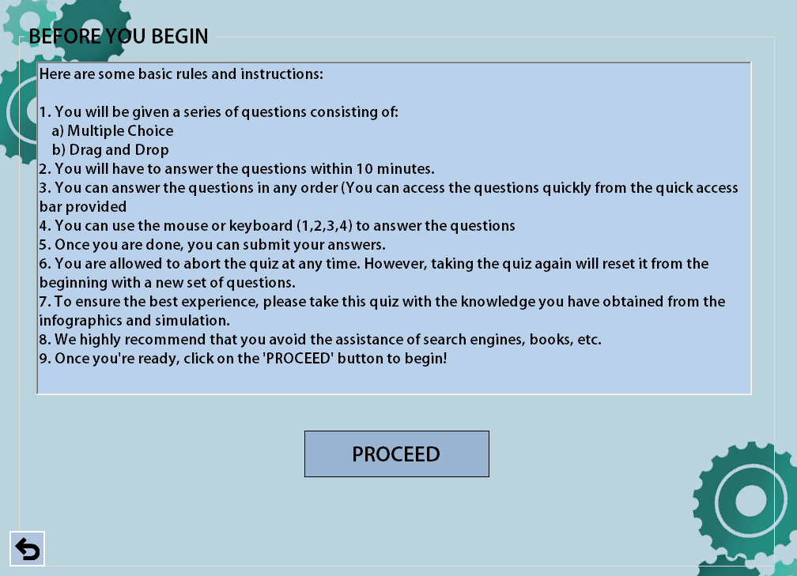The quiz segment will test you on how well you have understood the car systems from the infographics and simulation part. Selecting the option to take the quiz will take you to a page containing the quiz instructions as shown below:

Figure 3.1: The Instructions Page

## During the quiz

* A series of questions will be provided to you and you will be required to answer them within 10 minutes.
* The segment on the left will be where the question will be while the segment on the right will be where the answers are, as shown in Figure 3.2.
* Answers can be selected using the keyboard in accordance to the number for the question (e.g. pressing ‘1’ for answer ‘1’). Pressing ‘Enter’ will submit that answer for the question and will move on to the next question.
* Questions can be in the form of text or image and you will be required to select the most befitting answer from the answer section.
* You are free to answer the questions in any particular order and can access questions quickly from the quick access bar above the question.
* You are allowed to abort the quiz midway but no statistics will be recorded and upon starting the quiz again, you will have to begin from the start once more.

Question

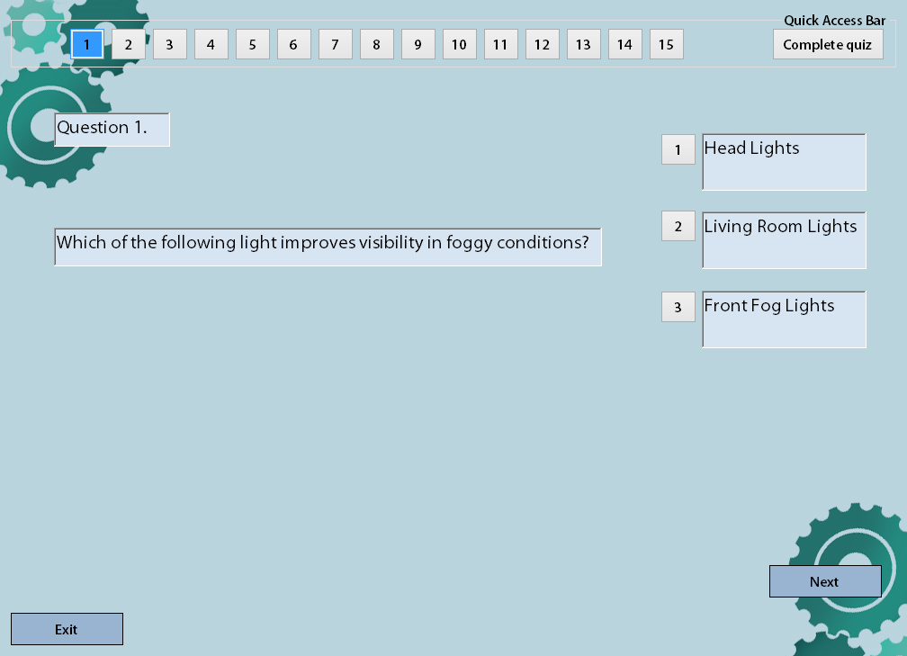

Quick Access Bar

Answers

Figure 3.2: An Example of the quiz question

## Results

* After all questions have been answered, a final page showing you the summary of your progress through the quiz, including number of questions answered and unanswered.

You will then obtain your results after registering your confirmed answers as shown in the figure 3.3. [WARNING: You will not be able to change your answer after submitting your answers after this page].

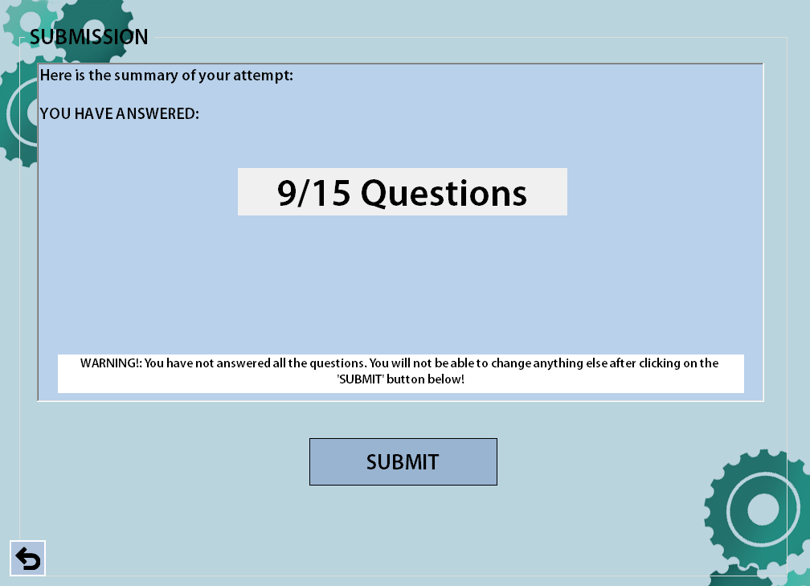

Figure 3.3: The confirmation page

* You are able to review the questions that you have answered to find out which ones you have gotten right or wrong by using the quick access bar. Questions, which are right, are highlighted in ‘green’ while answers, which are wrong, are highlighted in ‘red’ on the access bar.
* By clicking on an incorrect question on the access bar (RED):
  + The answer highlighted in ‘red’ is the answer you have chosen (which is wrong).
  + The answer highlighted in ‘green’ is the correct answer.
* By clicking on an correct question on the access bar (GREEN):
  + The answer is highlighted in ‘green’.
* Exiting from any point during the reviewing phase will return you to the main menu.

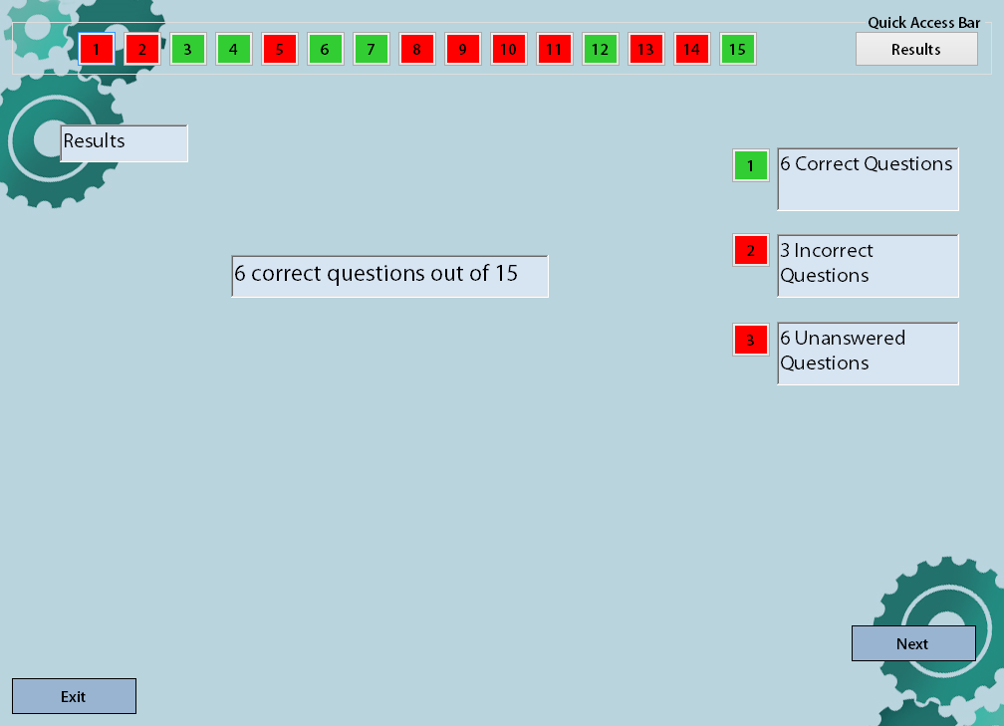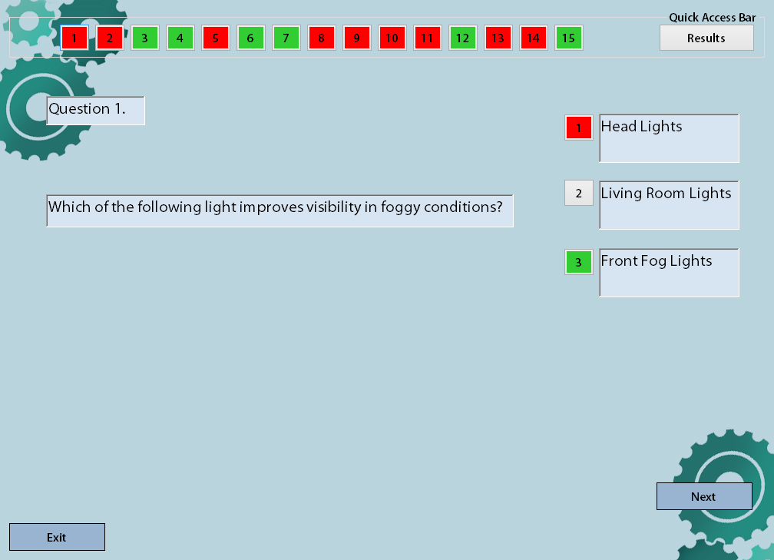

Figure 3.4: The Results Page

Figure 3.5: When Reviewing an Incorrect Question